

Amtrak Corporate Communications • [MediaRelationsChicago@Amtrak.com](mailto:MediaRelationsChicago@Amtrak.com)

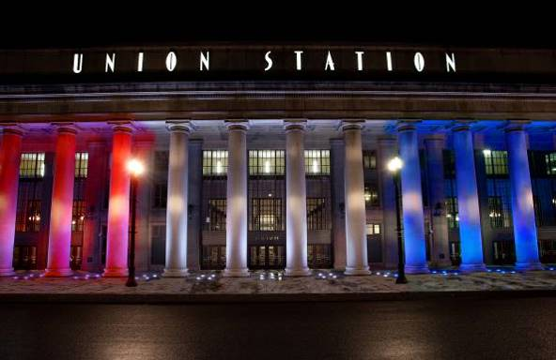[Chicago Union Station](https://www.ChicagoUnionStation.com) is owned by Amtrak, which is formally known as the National Railroad Passenger Corporation. Amtrak was created by Congress in 1970 and has operated most of the nation’s intercity passenger trains since 1971. A [designated landmark](https://www.landmarks.org/preservation-programs/richard-h-driehaus-foundation-preservation-awards/chicago-union-station-chicago/), Union Station is the busiest rail passenger terminal in Chicago and the most intact of what were once six major downtown stations.

***Fast Facts***

**Since 2016, Amtrak and our partners have invested more than $70 million to prepare the station for its next 100 years.**

Up to 56 Amtrak trains come and go from Union Station every day, with more than 3 million Amtrak customers using the station annually. It is the fourth busiest Amtrak station nationwide.

The average daily passenger trips for Metra is 65,300, for an annual total of more than 23 million trips.

In a typical year Amtrak controls more than 147,000 train movements at the station, an average of 409 per day, and more than 1,200 annual operations of the nearby [South Branch Bridge](https://assets.amtrakconnectsus.com/uploads/2025/02/PXL_20250103_163909549-EFFECTS-1-1157x1536.jpg),

Since 1972, all Amtrak services in Chicago originate and terminate here, fulfilling famed Chicago architect Daniel Burnham’s 1909 vision of all intercity trains using the same station without the confusing station transfers, complicated railcar movements, difficult baggage forwarding, and complex ticketing previously endured by generations of travelers.

The station was founded in 1913 by five railroads that have since been absorbed by other lines and no longer exist as independent firms. The names of these railroads are remembered on windows between the Canal Street entrances to Union Station and the Great Hall.

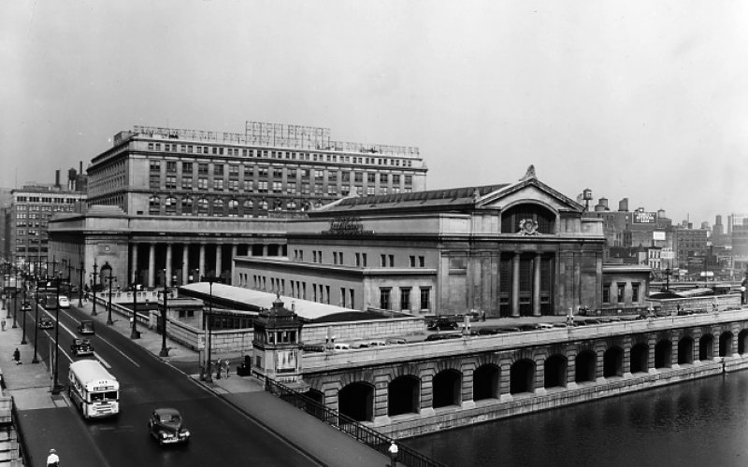Union Station opened in May 1925 after ten years of construction at a cost of $75 million. That would equal more than $1.3 billion in 2025 dollars. Burnham ("Make no small plans: they have no magic to stir men's blood") died before construction began and the work was completed by Graham, Anderson, Probst and White, his successor.

The exterior of the station is clad in Bedford limestone and was quarried in Indiana. Union Station is the only example in the United States of a “double-stub” station, where the 24 tracks approach from two directions and most do not continue under or through the station. The office tower in the “Headhouse Building” rises eight stories and occupies a full city block at Jackson Boulevard and Canal, Adams and Clinton Streets.

When the station was dedicated in July 1925, Union Station consisted of the Headhouse west of Canal Street and a “Concourse Building” between Canal Street and the Chicago River. In the 1930s, air rights above the tracks were sold for the construction of facilities for the Chicago Daily News newspaper and what was then the nation’s largest Post Office. The buildings have since changed owners and uses. The Concourse Building was demolished when the owning railroads sold those air rights in 1969, prior to the creation of Amtrak.

The station has been wholly owned by Amtrak since 1984, when the remaining Chicago Union Station Co. ownership shares were purchased by Amtrak from what are now known as the BNSF and the CPKC Railways.

-2-

A 1991 Concourse renovation changed the flow of passenger traffic through the station to separate Amtrak guests from those passengers using local Metra trains, but it has become congested by ridership growth on both Amtrak and Metra. **These issues are being addressed by** [**CHIP, the Chicago Hub Improvement Program**](https://www.amtrak.com/content/dam/projects/dotcom/english/public/documents/corporate/chicago-hub-improvement-program-fact-sheet.pdf)**,** a **partnership with others focused on upgrading the Concourse to smooth the flow of a growing number of passengers, to provide more amenities, increase accessibility, and to improve the servicing and routing of Amtrak trains to and from the station.**

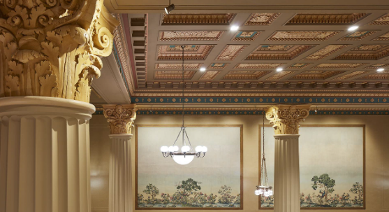The railroads that had shared ownership of the station abandoned the system that cooled the Great Hall circa 1960. In 2011, Amtrak restored Great Hall air conditioning and Amtrak guests now use it as a waiting area. In 2016, the hall’s grand staircases were restored, a new Metropolitan Lounge for premium Amtrak customers opened and elevator accessibility was created on Canal Street. The Burlington Room was developed for galas, corporate receptions, weddings, and other events. Commercial activations and other activities are welcomed in and around the Great Hall. Visit [ChicagoUnionStation.com](http://chicagounionstation.com/) or email [Events@ChicagoUnionStation.com](mailto:Events@ChicagoUnionStation.com) for more information.

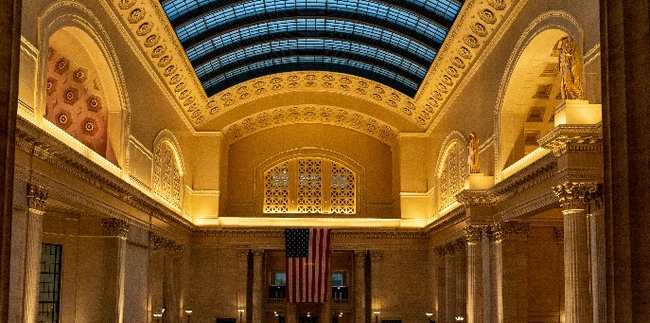A physical attraction at Union Station is the Great Hall, with a barrel-vaulted skylight that was blacked-out during World War II to make the station less of a target for enemy aircraft. It was not cleared until 1981. Completed in 2019 was a $22 million project to restore the original colors and make the Great Hall 50% brighter with a restored skylight and second one above to protect it. Two [Henry Hering](https://en.wikipedia.org/wiki/Henry_Hering) figural statues tower over the Great Hall on its east wall, one representing day (holding a rooster) and the other representing night (holding an owl), a recognition of the 24-hour nature of passenger railroading.

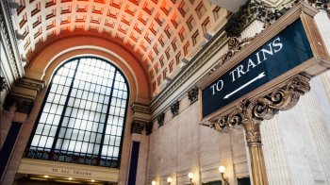The southernmost grand staircase into the Great Hall from Canal Street was used in a memorable scene from the motion picture “The Untouchables.” Tourists from around the world take their own pictures of both staircases. [Many films and television programs](https://resources.depaul.edu/newsroom/news/press-releases/Pages/windy-city-in-motion.aspx) have used the Great Hall, along with commercials, wedding, and engagement photos.

In 1992, Amtrak purchased a parking structure in the block bordered by Jackson Boulevard, Canal, Clinton and Van Buren Streets, immediately south of the current Headhouse and connected it to the Concourse with an underground pedway. As the structure was nearing the end of its useful life, Amtrak sold it in 2019. Since 2016, the pedway now serves both the Chicago Transit Authority’s Union Station Transit Center and the 320 South Canal Building, opened in 2022.

Proceeds from the sale of the parking structure created an accessible Clinton Street entrance to the Headhouse where none previously existed. Art from each of the six levels of that parking structure was saved and now serves as temporary decoration at that entrance, which has provisions for commercial tenants.

Amtrak is seizing a once-in-a-lifetime opportunity to transform rail and [Retrain Travel](https://media.amtrak.com/2024/10/retrain-travel-30-second-commercial/). By modernizing, enhancing, and expanding trains, stations, and infrastructure, Amtrak is meeting the rising demand for train travel. Amtrak offers unforgettable experiences to more than 500 destinations across 46 states and parts of Canada. Learn more at [Amtrak.com](https://www.amtrak.com/home.html), download the [Amtrak app](https://www.amtrak.com/mobile), connect with us on [X](https://x.com/Amtrak), [Instagram](https://www.instagram.com/amtrak), [Facebook](https://www.facebook.com/Amtrak/), and [LinkedIn](https://www.linkedin.com/company/amtrak), and join [Amtrak Guest Rewards](https://www.amtrak.com/guestrewards/home) to start earning points toward Amtrak reward travel, upgrades, gift cards and more.